Onboarding Coordinator


🎯 Training Overview

Welcome to Your OC Journey!

Congratulations on completing your foundational training! You're now entering the role-specific phase where you'll master the operational and technical skills that make a world-class Onboarding Coordinator.

🎯 Your Mission as an OC

As an Onboarding Coordinator, your role is built on 4 core pillars:

- BackOffice & Beep Store Setup: Configure the BackOffice and set up the Beep store, including uploading pictures and writing store descriptions
- Manage Beep Collateral Requests: Handle requests from both merchants and internal teams efficiently
- Collateral Fulfillment: Ensure all collateral requests are fulfilled within the 3-day SLA
- Coordinate Collateral Delivery: Align with third-party vendors to arrange timely delivery
- Manage GHL Setups in the Backoffice: Handle GHL configurations and integrations within the BackOffice system

You're the operational backbone of merchant onboarding—ensuring every merchant has a beautifully configured store and all the materials they need to launch successfully.
You're not just setting up accounts- you're enabling merchant success through flawless execution and on-time delivery.

📅 Your 2-Day Journey Timeline

Foundation (Already Completed!)
Day 1-2: Generic Training
- ✅ All-in-One StoreHub Product Knowledge
- ✅ System Navigation & Merchant Profile Basics
- ✅ Hardware Demo & Foundational Quiz (50% of final score!)

Specialization Begins Now
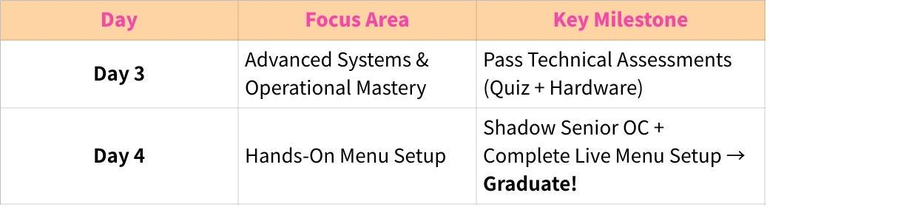
Click the image to view the sheet.
Note: OC training is streamlined- no mock test required! Your final evaluation is the Menu Setup task, which demonstrates real-world capability.

📅 Your Detailed Training Schedule

Day 3: Advanced Systems & Operational Mastery
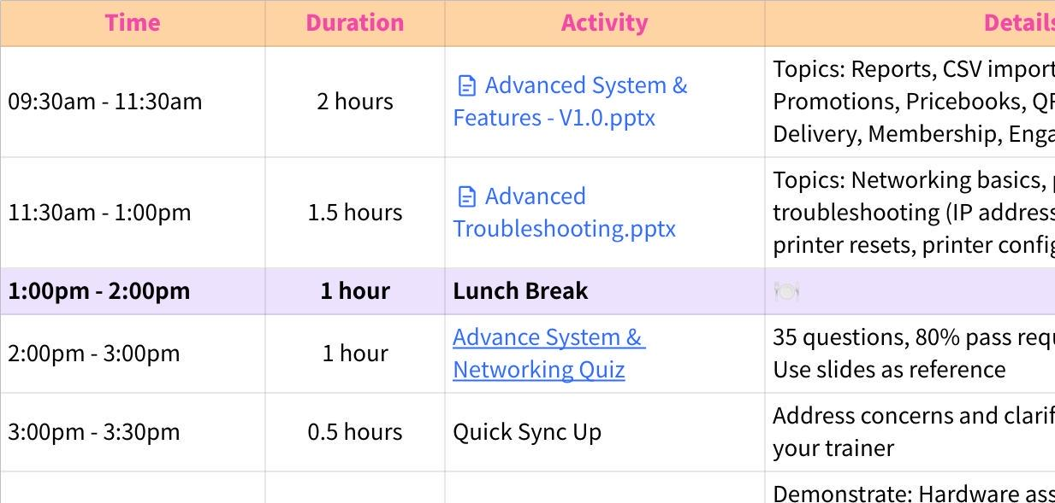
Click the image to view the sheet.

Day 4: Hands-On Menu Setup & Graduation
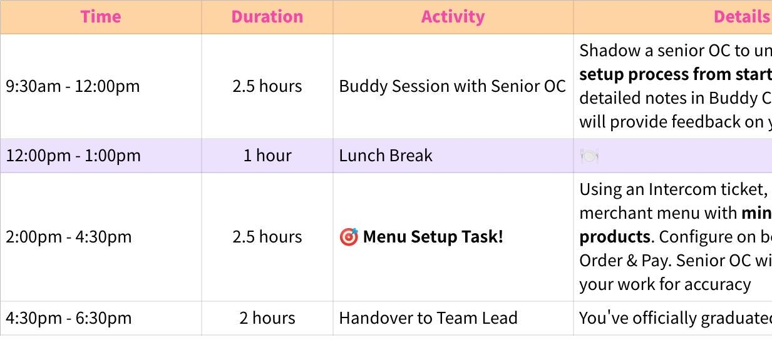
Click the image to view the sheet.

Milestones You'll Complete

Milestone 1: Advanced Systems Mastery (Day 3)

What You'll Learn:
- Advanced system features (reports, CSV import/export, promotions, pricebooks)
- Specialized features (QR Order & Pay, Beep Delivery, Membership, Engage)
- Basic networking and printer troubleshooting for merchant support
- Internal operational tools (Intercom, Aircall, supply chain workflows)

Assessments:
- Advance System & Networking Quiz (35% of final score)
- 35 questions, 80% passing score
- Open-book test using training slides
- No retakes- review thoroughly before submitting!

- Hardware Assessment (15% of final score)
- Live demonstration with your trainer
- Scenarios include: hardware assembly, printer search, kitchen printer setup, POS printer assignment, WiFi connection, Beep Order register assignment, and troubleshooting "can't find printer"
- 80% passing score required

By End of Day 3:
- You'll have mastered the technical foundations needed for operational excellence

Milestone 2: Hands-On Menu Setup Mastery (Day 4)

What You'll Do:
- Buddy Session with Senior OC (2.5 hours)
- Shadow a senior OC to learn the end-to-end menu setup process
- Take detailed notes in the provided Buddy Checklist
- Senior OC will review your performance and leave feedback
- Pro Tip: This is your chance to see the workflow in action—ask detailed questions about edge cases!

- Menu Setup Task (Final Practical Assessment)
- You'll receive a real Intercom ticket from a merchant
- Set up a menu with minimum 20 products
- Configure products on both Beep and QR Order & Pay
- Senior OC will cross-check your setup for accuracy
- This demonstrates you're ready for independent work!

Why This Matters: The Menu Setup task is your final evaluation- it replaces the mock test. This hands-on assessment proves you can execute the core OC responsibility: flawless menu configuration.

Graduation: Upon completing the Menu Setup task with 80%+ accuracy, you'll officially graduate training and transition to your Team Lead for full onboarding into your OC role.

🎓 Your Complete Assessment Breakdown

Formal Assessments (80% Total)
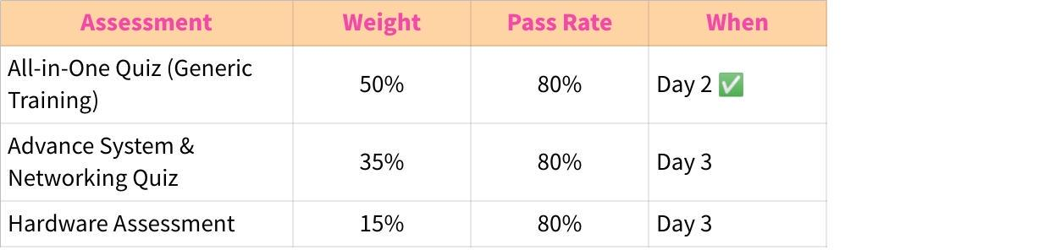
Click the image to view the sheet.
Formal Assessments Subtotal: 100%

Key Insight: For OCs, the All-in-One Quiz carries the highest weight (50%) because deep product knowledge is essential for accurate menu setup and merchant support. The Menu Setup task on Day 4 is your final practical evaluation but is pass/fail, not weighted.

📊 Participation Score (5% - 20%)

Your active engagement throughout training is evaluated daily by your trainer and can add 5% to 20% to your overall score.

This means your true final score range is 0% - 120% (100% from assessments + up to 20% from participation).

How Participation is Scored
Your trainer evaluates you across 3 categories:
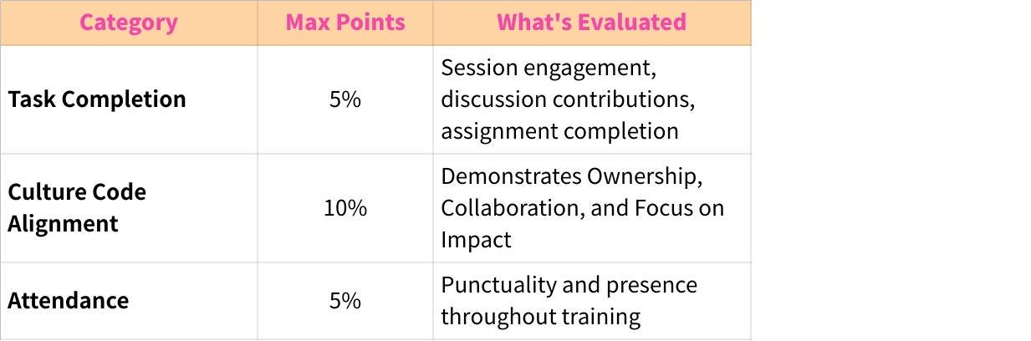
Click the image to view the sheet.

Participation Scoring Rubric
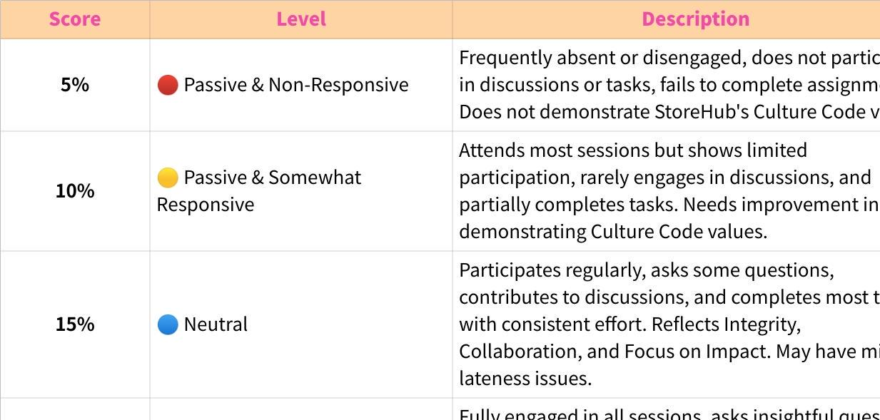
Click the image to view the sheet.

Attendance Policy
- Medical Leave (MC), Emergency Leave (EL), Unpaid Leave (UPL), or Immediate Family Bereavement are excused and do not negatively impact your attendance score
- Unexcused absences or chronic lateness will affect your participation score

Who Scores Participation?
Your trainer (Andrea) tracks your daily engagement and assigns your participation score at the end of training.

Pro Tips for Maximizing Your Participation Score:
- Be Present & Punctual - Show up on time, every time
- Engage Actively - Ask questions during sync-ups, share insights during buddy sessions
- Complete Tasks Thoroughly - Don't just finish assignments- excel at them
- Take Detailed Notes - Especially during the buddy session- your notes will be reviewed
- Embody Culture Code - Demonstrate ownership of your learning journey
- Help Your Peers - Collaboration is valued- support fellow trainees when appropriate

Remember: Participation isn't about being the loudest voice- it's about being consistently curious, accountable, and professional.

👥 Your Coach & Support System

Who is Your Coach?

Your coach (also referred to as your Team Lead or trainer for assessments) is assigned based on your country/region:

Click the image to view the sheet.
What Your Coach Does:
- Conducts your Hardware Assessment (Day 3)
- Arranges your Buddy Session with a senior OC (Day 4)
- Evaluates your Menu Setup task (Day 4)
- Provides feedback and scores your performance
- Becomes your direct manager post-graduation

When to Reach Out:
- If you're stuck on training materials
- To confirm your buddy session schedule
- For clarification on the Menu Setup task requirements

Trainer's Role:
- Coordinates scheduling between you, your coach, and senior OCs
- Tracks your progress through the training program
- Conducts the Hardware Assessment
- Available for logistical support (not technical content)

📚 Resources & Self-Study Tips

Your Training Materials
All slides and resources are provided in your training folder. Key materials include:
- Advanced System & Features - V1.0.pptx
- Advanced Troubleshooting.pptx
- [OC] Tools & Supply Chian.pptx
- Brand Servicing.pptx
- Buddy Checklist (provided Day 4)
- Intercom ticket for Menu Setup task (provided Day 4)

Self-Study Best Practices
- Follow the schedule strictly- each module builds on the previous one
- Take detailed notes - you'll reference them during open-book quizzes and practical work
- Master the menu setup process during the buddy session - this is what you'll be evaluated on!
- Don't hesitate to ask questions during sync-up sessions
- Practice thinking like a merchant- understanding merchant needs will make your setups better

Special Focus for OCs
- Attention to Detail: Menu setup requires precision—one wrong configuration can impact merchant operations
- SLA Awareness: You'll manage a 3-day SLA for collateral fulfillment—build time management habits now
- Tool Proficiency: Master Intercom and BackOffice—these are your daily tools

🚀 Ready to Excel?
You've already proven yourself by passing the foundational training. Now it's time to specialize and become the operational expert merchants rely on for flawless onboarding.
Your Checklist:
- Review this overview thoroughly
- Ensure you have access to all training materials
- Confirm your coach assignment with your trainer
- Verify you have BackOffice account access for Day 4 menu setup
- Set up your Buddy Checklist access for Day 4
- Get ready to dive into Day 3 content!
Remember: This is a self-study journey, but you're never alone. Your coach, trainer, and senior OC buddies are here to support you every step of the way.

Now go forth and become an exceptional Onboarding Coordinator! 💪

